PMagic Web Application

- documentation -

1. Login

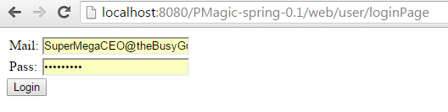

2. Types of "homePage"s:

2.1. Admin (local terminology - SuperMegaCEO)

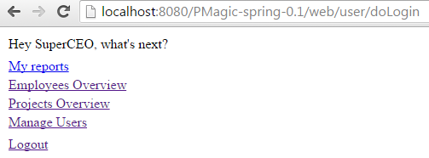

2.2. Employee

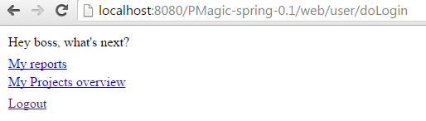

Unfortunately, the employee doesn't do anything! For the moment, there are no entities to link the employee and project, in order to report the worked hours.

3. What can the SuperCEO do?

Employees Overview link displays a list of all employees (Employee entities):

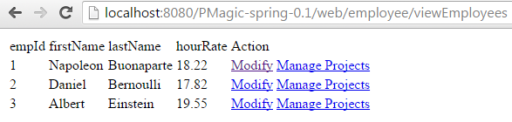

"Modify" gets us to:

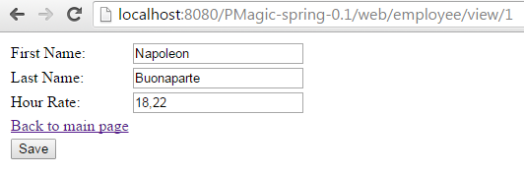

"Manage Projects" displays a list of all projects assigned to the current Employee. The projects can only be added and deleted:

TODO--------------------------here goes the screenshot---------------------------------------

"Projects Overview" link allows projects to be added and changed:

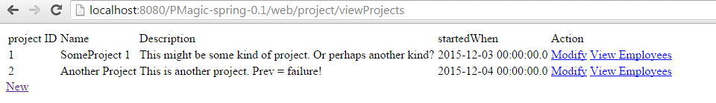

When modifying the project ("Modify"):

